2015 St. Patrick’s Day Dinner
Thank you to all who helped make the St. Patrick’s Day Dinner a success. A special thanks to all who helped with the dinner set-up / clean-up efforts, bought / sold tickets, and donated to the raffles. The event was a success because so many of Knights and other volunteers shared their time and talents.
At the end of the day:
Over 230 attended the dinner
$1,375 was raised by the Vocations Scholarship support raffle
$2,440 was raised by the dinner and raffles

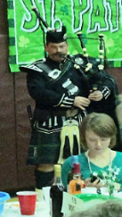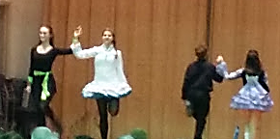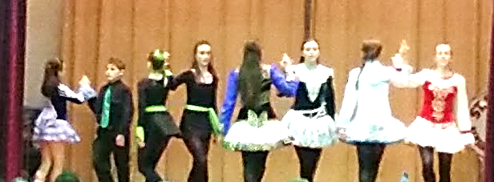
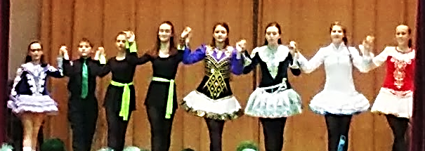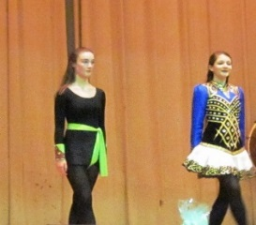
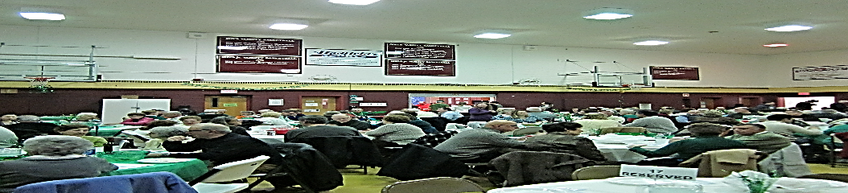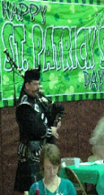

Vocation Raffle Winners:
1st Prize: Anthony J. Wassil
2nd Prize: Richard Luddy
3rd Prize: Stephen Kulinski
4th Prize: Rebecca Lukaszewski (Richard Rampone)

