2016 St. Patrick’s Dinner
Thank you to all who helped make the St. Patrick’s Dinner a success. A special thanks to all who helped with the dinner set-up / clean-up efforts, bought / sold tickets, and donated to the raffles. The event was a success because so many of Knights and other volunteers shared their time and talents.
At the end of the day:
Over 220 attended the dinner
$1,000 was raised by the Members’ raffle for youth and vocations
$2,000 was raised by the dinner and raffles

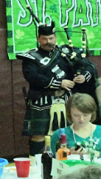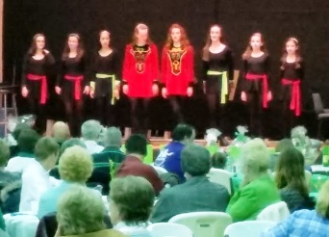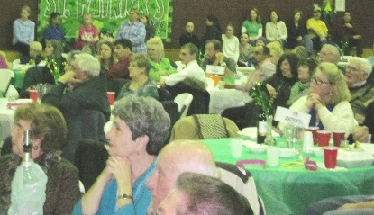
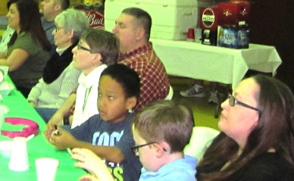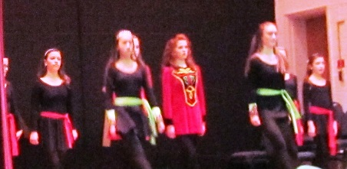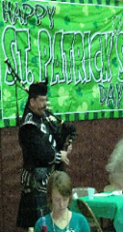

Vocation Raffle Winners:
1st Prize: Ralph Hedenberg, Jr.
2nd Prize: George Soliwoda
3rd Prize: John Conti
4th Prize: Gary Egri
5th Prize Gary Egri

